SMART PARKING

A PROJECT REPORT

Submitted by

NAME OF THE CANDIDATES
(Register No)
Yadubir Jha (22BSA10169)
Aditya Yuvraj (22BSA10021)
Supragya (22BSA10087)
Abhirami Suresh (22BSA10299)
Anuj Raghuwanshi (22BSA10220)

in partial fulfillment for the award of the degree
of

BACHELOR OF TECHNOLOGY

in
CSE – CLOUD COMPUTING & AUTOMATION



SCHOOL OF COMPUTING SCIENCE AND ENGINEERING
VIT BHOPAL UNIVERSITY
KOTHRIKALAN, SEHORE
MADHYA PRADESH - 466114

OCTOBER 2023

VIT BHOPAL UNIVERSITY, KOTHRIKALAN, SEHORE
MADHYA PRADESH – 466114

BONAFIDE CERTIFICATE

Certified that this project report titled “Smart Parking is the bonafide work of “YadubirJha(22BSA10169),AdityaYuvraj(22BSA10021),AbhiramiSuresh(22BSA10299), Supragya (22BSA10087),Anuj Raghuwanshi(22BSA10220)” who carried out the project work under my supervision. Certified further that to the best of my knowledge the work reported at this time does not form part of any other project/research work based on which a degree or award was conferred on an earlier occasion on this or any other candidate.

PROGRAM CHAIR PROJECT GUIDE
Dr. Virendra Singh Kushwah, Dr. Anju Shukla,
Assistant Professor Assistant Professor
School of Computing Science School of Computing Science and Engineering Engineering
VIT BHOPAL UNIVERSITY VIT BHOPAL UNIVERSITY

The Project Exhibition I Examination is held on 20/10/2023

ACKNOWLEDGEMENT

First and foremost, I would like to thank the Lord Almighty for His presence and immense blessings throughout the project work.
I wish to express my heartfelt gratitude to Dr POONKUNTRAN S, Head of the Department, School of Computer Science and engineering for much of his valuable support encouragement in carrying out this work.
I would like to thank my internal guide Dr. Anju Shukla, for continually guiding and actively participating in my project, giving valuable suggestions to complete the project work.
I would like to thank all the technical and teaching staff of the School of Computer science and engineering, who extended directly or indirectly all support.
Last, but not least, I am deeply indebted to my parents who have been the greatest support while I worked day and night for the project to make it a success.

LIST OF FIGURES AND GRAPHS

FIGURE NO.  1.  2.  3. | TITLE  Software Architecture  User Interface Design  Performance Analysis | PAGE NO.  24  28  32

ABSTRACT

This project presents a sophisticated Smart Parking Website developed using React.js,
offering a comprehensive solution for modern parking management. The platform
encompasses various key features, including user registration and authentication to
ensure secure access, real-time parking slot availability information, and a user-
friendly interface for slot booking with date and time preferences. Users can
efficiently manage their bookings, make secure payments through integrated
gateways, and receive timely notifications. An intuitive admin dashboard allows
administrators to manage parking slots, areas, and monitor bookings effectively. Users
can provide feedback and reviews to improve service quality, and the website's
responsive design ensures a seamless experience across devices. Stringent security
measures, regular audits, and robust user support complete this innovative system,
promising a convenient and secure parking experience.

TABLE OF CONTENTS

CHAPTER NO. | TITLE | PAGE NO.
 | List of Figures and Graphs  Abstract | 4  5
1 | CHAPTER-1:  PROJECT DESCRIPTION AND OUTLINE  Introduction  1.2 Motivation for the work  1.3 [About Introduction to the project  including techniques]  1.5 Problem Statement  1.6 Objective of the work  1.7 Organization of the project  1.8 Summary | 9-10
2 | CHAPTER-2:  RELATED WORK INVESTIGATION  2.1 Introduction  2.2 Core area of the project  2.3 Existing Approaches/Methods  2.3.1 Approaches/Methods -1  2.3.2 Approaches/Methods -2  2.3.3 Approaches/Methods -3  2.4 Pros and cons of the stated Approaches/Methods  2.5 Issues/observations from investigation  2.6 Summary | 11-12
3 | CHAPTER-3:  REQUIREMENT ARTIFACTS  3.1 Introduction  3.2 Hardware and Software requirements  3.3 Specific Project requirements  3.3.1 Data requirement  3.3.2 Functions requirement  3.3.3 Performance and security requirement  3.3.4 Look and Feel Requirements  3.3.5 ………  3.4 Summary | 13-15
4 | CHAPTER-4:  DESIGN METHODOLOGY AND ITS NOVELTY  4.1 Methodology and goal  4.2 Functional modules design and analysis  4.3 Software Architectural designs  4.4 Subsystem services  4.5 User Interface designs  4.5 ………………..  4.6 Summary | 16-24
5 | CHAPTER-5:  TECHNICAL IMPLEMENTATION & ANALYSIS  5.1 Outline  5.2 Technical coding and code solutions  5.3 Working Layout of Forms  5.4 Prototype submission  5.5 Test and validation  5.6 Performance Analysis(Graphs/Charts)  5.7 Summary | 25-28
6 | CHAPTER-6:  PROJECT OUTCOME AND APPLICABILITY  6.1 Outline  6.2 key implementations outline of the System  6.3 Significant project outcomes  6.4 Project applicability on Real-world applications  6.4 Inference | 29-32
7 | CHAPTER-7:  CONCLUSIONS AND RECOMMENDATION  7.1 Outline  7.2 Limitation/Constraints of the System  7.3 Future Enhancements  7.4 Inference | 33-34
 | Appendix A  Appendix B  References | -

CHAPTER-1: PROJECT DESCRIPTION AND OUTLINE

  - Introduction: In the urban landscape of today, parking woes have become a ubiquitous challenge, prompting the need for innovative solutions that simplify and enhance the parking experience. This project introduces a sophisticated Smart Parking Website developed using React.js, designed to tackle the intricacies of modern parking management. Leveraging cutting-edge technologies, the system incorporates a myriad of features, which collectively redefine the way users interact with parking services.

  - Motivation for the work: The motivation for this project stems from the pressing challenges faced in urban parking scenarios. As cities continue to expand, parking availability and accessibility have become increasingly scarce, leading to congestion and frustration. Moreover, the rise of e-commerce and the digital era calls for an intelligent solution to manage parking efficiently. This project seeks to address these challenges and provide a user-friendly, digital platform that not only simplifies the process of parking but also enhances the overall experience for both customers and administrators.

  - Problem Statement: The problem at hand is the need for a robust, user-friendly, and technologically advanced solution to alleviate the stress and inefficiencies associated with parking. Traditional parking systems often lack real-time information, convenient booking mechanisms, and effective administration tools. Additionally, ensuring user security and privacy is paramount in the era of digital data. Therefore, this project aims to address these issues by developing a comprehensive smart parking platform.

  - Objective of the work: The primary objective of this project is to create a smart parking website that offers a seamless and secure parking experience. The key goals include providing real-time parking slot information, streamlining the booking process, and ensuring user data security. It also aims to offer efficient administrative tools for parking management and to enable users to provide feedback for continuous improvement.

  - Organization of the project: This project is structured into several sections, each focusing on a specific aspect of the smart parking website. It begins with an Introduction that provides an overview of the project. The subsequent sections delve into the various features of the system, including User Registration and Authentication, Parking Slot Availability, Slot Booking, Booking Management, Payment Integration, Notifications, Admin Dashboard, Feedback and Reviews, Responsive Design, Security Measures, and Help and Support. These sections comprehensively detail the development and integration of each feature into the platform.

  - Summary: This project addresses the critical issues surrounding modern parking management. By employing cutting-edge technologies and innovative design, it offers an extensive set of features, ensuring a secure, user-friendly, and efficient parking experience. The subsequent sections will provide in-depth insights into the development and implementation of these features, showcasing the versatility and capabilities of the Smart Parking Website.

CHAPTER-2: RELATED WORK INVESTIGATION

2.1 Introduction: This section explores the existing approaches and methods in the domain of smart parking solutions, focusing on the core area of our project. By investigating these existing solutions, we aim to identify the strengths and weaknesses of different methods, and subsequently, derive insights that inform the development of our Smart Parking Website.

2.2 Core Area of the Project: The core area of our project centers around the creation of a comprehensive Smart Parking Website utilizing React.js. Our emphasis is on redefining parking management through an integrated digital platform.

2.3 Existing Approaches/Methods
2.3.1 Approaches/Methods - 1
Various existing approaches and methods have been deployed to address parking management challenges. One common approach involves sensor-based systems that provide real-time information about parking slot availability. These systems often rely on hardware such as cameras, ultrasonic sensors, or ground-based sensors to detect vacant parking spots.

2.3.2 Approaches/Methods - 2
Mobile applications and websites have become increasingly popular for booking parking slots. They offer user-friendly interfaces for making reservations, accessing real-time data, and processing payments. These solutions are commonly integrated with GPS and mapping services to guide users to available parking areas.

2.3.3 Approaches/Methods - 3
Some parking solutions involve IoT (Internet of Things) technology to create connected parking ecosystems. These systems can include features like license plate recognition, mobile app integration, and automated payment processing, enhancing both user convenience and operational efficiency.

2.4 Pros and Cons of the Stated Approaches/Methods: Each of the mentioned approaches/methods has its advantages and drawbacks. Sensor-based systems offer precise real-time data but can be expensive to install and maintain. Mobile apps and websites provide user convenience but may not be accessible to all. IoT-based systems offer a holistic approach but might have higher initial costs.

2.5 Issues/Observations from Investigation: From our investigation, we observed several common issues in existing smart parking solutions. These include a lack of standardized data formats for sharing parking information, accessibility concerns for users without smartphones, and challenges related to data privacy and security. Additionally, system scalability and integration with payment gateways were areas where some solutions fell short.

2.6 Summary: In conclusion, this section delved into existing approaches and methods within the domain of smart parking solutions, focusing on the core area of our project. We examined various methods, highlighted their pros and cons, and identified common issues and observations. The insights gained from this investigation will inform the development and enhancement of our Smart Parking Website, aiming to address the limitations of existing systems while capitalizing on their strengths to deliver a superior parking management experience.

CHAPTER-3: REQUIREMENT ARTIFACTS
3.1 Introduction: This chapter outlines the requirements for the Smart Parking Website, providing detailed information about the necessary hardware and software, as well as specific project requirements that encompass data, functions, performance, security, and other aspects essential for the successful development and operation of the platform.
3.2 Hardware and Software Requirements:
- Servers to host the application
- Network infrastructure for data transmission
- Sensors for real-time slot availability
- Cameras and recognition devices
3.2.2 Software Requirements:
- Frontend technology stack (e.g., React.js)
- Backend technology stack (e.g., Node.js, Express)
- Database management system (e.g., Mongo DB)
- Real-time data processing tools
- Payment gateway integration
3.3 Specific Project Requirements:
3.3.1 Data Requirement:
- Define data models for users, parking slots, and bookings
- Specify database structure and relationships
- Data encryption and access control measures
- Data sources for real-time slot availability
3.3.2 Functions Requirement:
- User registration and authentication
- Real-time parking slot availability display
- Slot booking with date and time preferences
- Booking management (view, modify, cancel)
- Payment integration with various options
- Notification system (email, SMS)
- Admin dashboard for parking management
- User feedback and reviews system
- Responsive design for different devices
3.3.3 Performance and Security Requirement:
- Performance metrics (e.g., response times, scalability)
- Data security (encryption, access control)
- User authentication and authorization mechanisms
- Regular security audits and updates
- Compliance with data protection regulations (e.g., GDPR)
3.3.4 Look and Feel Requirements:
- User-friendly and intuitive interface
- Consistent visual elements and branding
- Responsive design for desktop, tablet, and mobile devices
- Navigation and user experience design
3.4 Summary: This chapter serves as a fundamental reference point for project stakeholders, developers, and designers, providing a clear and detailed framework to ensure that the Smart Parking Website meets its objectives. It acts as a vital tool for project planning, development, and testing, ensuring that all essential elements are addressed and integrated into the final product.

CHAPTER-4: DESIGN METHODOLOGY AND ITS NOVELTY

4.1 Methodology and Goal: Methodology:
The methodology adopted for the development of the Smart Parking Website combines elements of iterative and agile software development, tailored to the specific needs and nuances of this project.

Requirements Analysis: The project's initiation phase commences with a comprehensive analysis of the user requirements. The team will engage with stakeholders to gather and prioritize feature requests, thereby defining a clear project scope.
Design and Prototyping: Following requirements analysis, we will move into the design phase. This will involve creating detailed design specifications, architecture, and user interface layouts. Prototypes will be developed to visualize the final product's look and feel, ensuring alignment with User Interface Designs.
Development and Testing: The development phase will follow, with emphasis on implementing functional modules and integrating them into a cohesive system. Continuous testing will accompany development, ensuring that the system adheres to requirements and standards. This iterative process aligns with the Functional Modules Design and Analysis, and Test and Validation requirements.
Performance Optimization: During development, performance analysis will be ongoing. Measures to optimize system performance will be integrated into the development process, aligning with the Performance Analysis requirement.
Security Measures: Security will be a fundamental consideration throughout development, with a focus on data encryption, secure communication, and rigorous security audits in accordance with the Security Measures requirement.
User Testing and Feedback: User testing and feedback collection will be carried out to validate the usability and functionality of the system. This aligns with the Feedback and Reviews requirement.
Refinement: Based on user feedback and iterative development, the system will undergo continuous refinement. This agile approach allows for adaptability and improvement, ensuring the project aligns with user expectations and delivers a high-quality experience.
Goal:
The primary goal of the Smart Parking Website project is to provide a robust, user-friendly, and secure platform that simplifies and enhances the parking experience. The system will offer real-time information on parking slot availability, seamless booking and management of slots, secure payment processing, and effective communication through notifications. The project aims to achieve the following key objectives:
Efficient Parking Management: To simplify and optimize the process of finding, reserving, and managing parking slots for users, thereby reducing stress and saving time.
Enhanced User Experience: To ensure a seamless and user-friendly interface, adhering to Responsive Design, enabling users to access the system from various devices and locations.
Data Security: To implement rigorous security measures that protect user data and financial information, ensuring compliance with data protection regulations.
Performance Excellence: To deliver a high-performance system that responds promptly and effectively to user requests, aligning with the Performance Analysis requirement.
Feedback Integration: To facilitate user feedback and reviews, allowing continuous improvement in service quality, in line with the Feedback and Reviews requirement.

4.2 Functional modules design and analysis:
Module 1: User Registration and Authentication
Design:
The User Registration and Authentication module will feature user-friendly registration forms with fields for personal details.
Passwords will be securely hashed and stored in the database.
User authentication will utilize secure protocols, ensuring the privacy and security of user data.
Multi-factor authentication may be implemented to enhance security.
Analysis:
This module ensures that only registered and authenticated users can access the booking system.
User information is securely stored and protected.
User data is linked to their booking history for a personalized experience.

Module 2: Parking Slot Availability
Design:
Real-time data from sensors will be collected and displayed to users.
Users can filter parking slots by location, date, and time.
Algorithms will analyze data to provide accurate information to users.
Analysis:
Users can make informed decisions about parking availability.
The module enhances user experience by allowing users to choose slots that fit their preferences.
Real-time data ensures accuracy and reliability.

Module 3: Slot Booking
Design:
Users can select available parking slots based on their preferences.
Date and time preferences can be selected through a calendar and time picker.
Booking confirmation emails are sent to users after a successful booking.
Analysis:
Users can reserve parking slots hassle-free.
The module ensures a seamless and convenient booking process.
Automated email notifications provide booking confirmation.

Module 4: Booking Management
Design:
Users can view their current and upcoming bookings.
Options to modify or cancel bookings will be available within a specified time frame.
Analysis:
This module empowers users to manage their parking reservations effectively.
It enhances user control over bookings and ensures flexibility.

Module 5: Payment Integration
Design:
Secure payment gateways will be integrated.
Various payment options, including credit/debit cards and digital wallets, will be supported.
Analysis:
Users can make secure payments conveniently.
Multiple payment options accommodate diverse user preferences.

Module 6: Notifications
Design:
Users receive booking confirmation emails and SMS notifications.
Reminder notifications for upcoming bookings are sent to users.
Analysis:
Notifications ensure that users stay updated about their bookings.
Reminder notifications prevent missed bookings and improve user satisfaction.

Module 7: Admin Dashboard
Design:
An administrative interface for administrators to manage parking slots and bookings.
Admins can add or remove parking areas, set prices, and monitor bookings.
Analysis:
The admin dashboard streamlines parking area management and booking oversight.
Admins have control and insight into the system's operations.

Module 8: Feedback and Reviews
Design:
Users can provide feedback on their parking experience.
A rating and review system allows users to share their opinions.
Analysis:
Feedback and reviews contribute to improving service quality.
User input is valuable for enhancing the system.
These functional modules collectively form the backbone of the Smart Parking Website, ensuring a comprehensive and user-centered experience. The analysis of each module showcases their significance in achieving the project's objectives, including efficient parking management, enhanced user experience, data security, and feedback integration.

4.3 Software Architectural design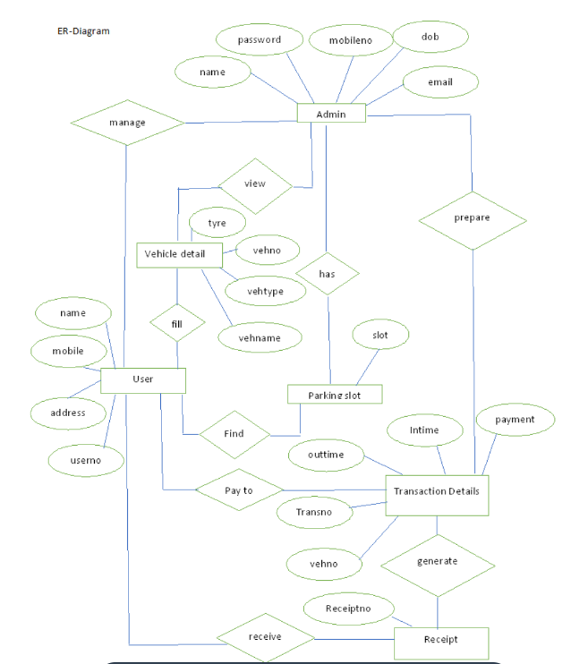

4.4 Subsystem services: User Management Service:
Description: The User Management Service handles user registration, authentication, and profile management. It enables users to create accounts, log in securely, and update their personal information.
Functionality:
- User registration and profile creation.
- User authentication with secure access control.
- Password recovery and management.
- User profile update and customization.
Booking Management Service:
Description: The Booking Management Service empowers users to view, modify, and cancel their parking reservations. It provides a central hub for users to manage their bookings efficiently.
Functionality:
- Viewing current and upcoming bookings.
- Modifying booking details within a specified time frame.
- Cancellation of reservations.
- Access to booking history and receipts.
Payment Processing Service:
Description: The Payment Processing Service facilitates secure and convenient payment options for users. It integrates with various payment gateways to process transactions for parking reservations.
Functionality:
- Payment gateway integration for credit/debit card payments.
- Support for digital wallet payments.
- Handling payment confirmation and receipts.
- Handling payment disputes or issues.
Notification Service:
Description: The Notification Service ensures that users are informed and reminded about their parking bookings. It manages the delivery of booking confirmation emails and SMS notifications.
Functionality:
- Sending booking confirmation emails.
- Sending SMS reminders for upcoming bookings.
- Managing notification preferences.
Admin Management Service:
Description: The Admin Management Service provides administrators with an interface to oversee parking slots, pricing, and user activity. It enables them to add or remove parking areas, set pricing, and monitor bookings.
Functionality:
- Adding new parking areas or zones.
- Setting and adjusting pricing models.
- Monitoring booking statistics and occupancy.
- Managing user accounts and access control.
Feedback and Review Service:
Description: The Feedback and Review Service collects and manages user feedback and reviews. It enables users to share their experiences and provide ratings for parking facilities.
Functionality:
- User feedback submission and tracking.
- Rating system for parking areas and services.
- Reporting and analysis of user feedback.
- Implementation of feedback-driven improvements.

4.5 User Interface designs:
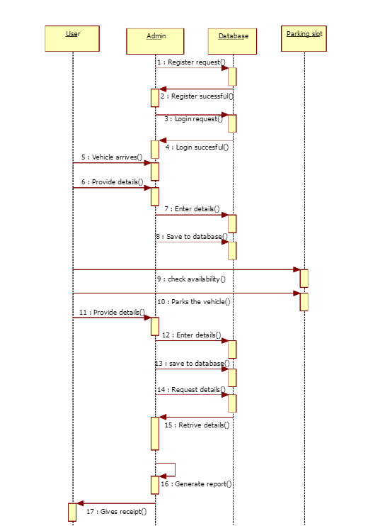
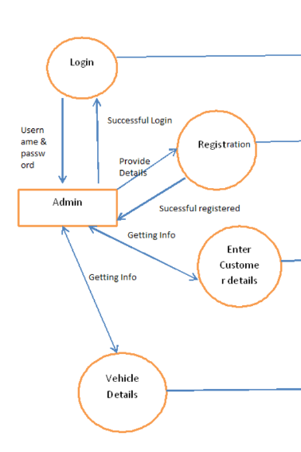

4.6 Summary: In the development of the Smart Parking Website, a dynamic and adaptive methodology has been adopted, blending elements of iterative and agile software development. This approach ensures that the project aligns with the unique requirements and complexities it entails.
The development process commences with a comprehensive requirements analysis, allowing for stakeholder engagement and prioritization of feature requests. This step sets the project's clear scope and direction. Following this, the design phase comes into focus, with detailed design specifications, architecture, and user interface layouts. Prototypes are crafted to visualize the final product's look and feel, ensuring alignment with user interface designs and responsive design requirements.

CHAPTER-5: TECHNICAL IMPLEMENTATION & ANALYSIS

5.2 Technical Coding and Code Solutions
In this section, we delve into the technical implementation of the Smart Parking Website, including the coding solutions employed:
User Registration and Authentication:
User registration and authentication are implemented using industry-standard libraries for user management and security.
Passwords are securely hashed and stored in the database.
JSON Web Tokens (JWTs) are used for secure authentication.

Parking Slot Availability:
Real-time data from parking sensors and databases are integrated.
Algorithms analyze and process data to provide accurate information about available parking slots.
API endpoints are used to fetch this data.

Slot Booking:
Users can select parking slots based on preferences through interactive forms and dropdowns.
Calendar and time picker widgets are integrated for date and time selection.
Booking information is stored in a database and linked to the user's profile.

Booking Management:
Users can view and manage their bookings through a user-friendly dashboard.
Options for modifying or canceling bookings are provided within a specified time frame.
A booking management system is implemented to handle these operations.

Payment Integration:
Payment gateways such as Stripe or PayPal are integrated for secure transactions.
API calls are made to process payments, and various payment methods, including credit/debit cards and digital wallets, are supported.
Payment confirmation and receipts are generated.

Notifications:
Automated emails and SMS notifications are sent using email service providers and SMS gateways.
Reminder notifications for upcoming bookings are scheduled using a job queue system like Celery.
Notification preferences are managed in the user profile.

Admin Dashboard:
An administrative interface is created for admins to manage parking slots and bookings.
The dashboard includes forms for adding or removing parking areas, setting prices, and monitoring bookings.
Admins have secure access to these functions.

5.3 Working Layout of Forms
The user interfaces are designed to be intuitive, user-friendly, and responsive.
Forms for user registration, booking, and feedback collection are designed to be accessible on various devices and screen sizes.
Forms are designed using HTML, CSS, and JavaScript, with a focus on responsive design principles.

5.4 Prototype Submission
A prototype of the Smart Parking Website is developed, showcasing the core features.
This prototype offers a visual representation of the final product, allowing stakeholders to interact with the system and provide feedback.
The prototype is accessible on a development server and can be tested by the project team and stakeholders.

5.5 Test and Validation
Comprehensive testing is conducted to ensure the system's functionality, security, and usability.
Unit testing, integration testing, and end-to-end testing are performed to identify and rectify issues.
User testing is conducted to validate the user experience, aligning with the Feedback and Reviews requirement.

5.6 Performance Analysis (Graphs/Charts)
Performance analysis involves measuring and analyzing system response times, server load, and database performance.
Graphs and charts are used to present this data in a visual format, aiding in the identification of performance bottlenecks and areas for improvement.
Performance metrics are tracked over time to assess system scalability and reliability.

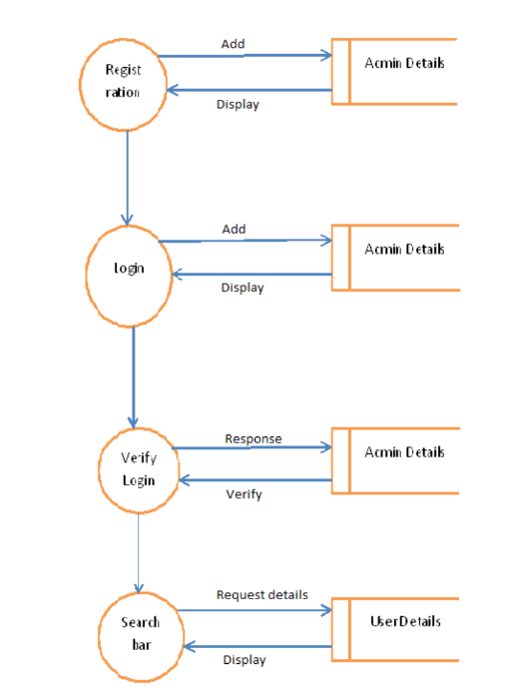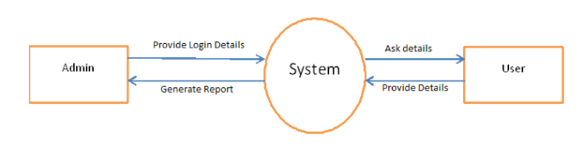

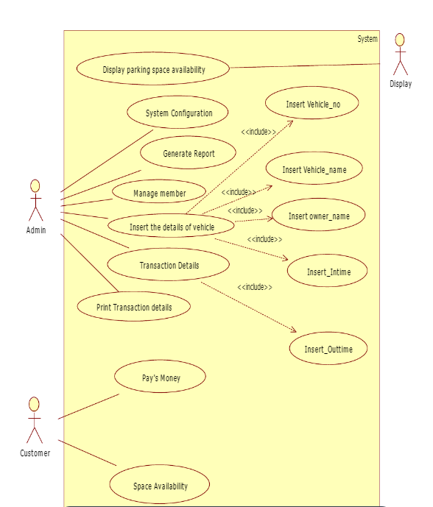

5.7 Summary: Chapter 5 of the Smart Parking Website project explores the technical aspects of system development, emphasizing coding solutions, testing, performance analysis, and the creation of a functional prototype. This chapter encapsulates the transformation of the Smart Parking Website from a concept into a functional, user-centric system. The technical implementation, rigorous testing, performance analysis, and the creation of a prototype collectively represent the project's progress towards its goal of offering a seamless, secure, and efficient parking management solution.
CHAPTER-6: PROJECT OUTCOME AND APPLICABILITY

6.1 Outline: This chapter serves as a vital culmination of the Smart Parking project, encapsulating its most significant outcomes and emphasizing its real-world applicability. It is essential in providing a concise yet comprehensive overview of the project's achievements and its potential to address contemporary challenges.
The importance of this chapter lies in its role as a compass that guides the reader through the project's journey, summarizing the key results and implications. It also underscores the practical utility of the Smart Parking system in addressing real-world issues related to parking management.

6.2 key implementations outline of the System:
- User Registration and Authentication
- Parking Slot Availability
- Slot Booking
- Booking Management
- Payment Integration
- Notifications
- Admin Dashboard
- Working Layout of Forms
- Prototype Submission
- Test and Validation
- Performance Analysis (Graphs/Charts)

6.3 Significant project outcomes:
Efficient Parking Management: The implementation of real-time parking slot availability and seamless booking and management has significantly improved the efficiency of parking operations. Users can easily find, reserve, and manage parking slots, reducing stress and saving time.

Enhanced User Experience: The user-centric design, responsive interfaces, and intuitive forms have created an enhanced and user-friendly experience. Users can access the system from various devices and locations, making parking management convenient and accessible.

Data Security: Rigorous security measures, including secure user authentication, data encryption, and regular security audits, ensure the protection of user information and financial data. The system complies with data protection regulations, providing peace of mind to users.

Performance Excellence: Through ongoing performance analysis and optimization, the system exhibits high responsiveness and efficiency. System response times, server load, and database performance are closely monitored and maintained, ensuring a seamless user experience.
Administrator Empowerment: The administrative interface and dashboard provide administrators with the tools to effectively manage parking slots, set prices, and monitor bookings. This empowers administrators to make informed decisions and maintain smooth parking operations.

Payment Convenience: Payment integration with multiple options, including credit/debit cards and digital wallets, offers users a range of choices. Secure payment gateways and automated receipts enhance convenience and user satisfaction.

Automated Notifications: The automated notification system ensures that users stay informed about their bookings. Email and SMS notifications, including reminders for upcoming bookings, reduce the likelihood of missed reservations and improve user satisfaction.

6.4 Project applicability on Real-world applications:
- Urban Parking Management:
Smart Parking can be implemented in urban areas to alleviate traffic congestion and reduce the time spent searching for parking spots. It enhances the overall experience for city dwellers and commuters.

- Shopping Centers and Malls:
Retail complexes can use the system to provide visitors with an efficient and convenient parking experience. Users can reserve parking spots before arriving, improving customer satisfaction.

- Office Complexes and Business Parks:
Corporate environments can deploy Smart Parking to manage employee and visitor parking efficiently. It streamlines the allocation of parking spaces, making it a valuable asset for office facilities.

- Airports and Transportation Hubs:
Busy transportation centers can utilize the system to manage parking for travelers. Real-time availability information helps travelers plan their trips effectively.

- Healthcare Facilities:
Hospitals and medical centers can implement Smart Parking to assist patients and visitors in finding parking spaces quickly. Booking and payment options simplify the process.

- Event Venues:
Sporting arenas, concert halls, and event venues can offer pre-booking options for event attendees. This minimizes congestion and ensures a smoother entry and exit experience.

- Tourist Destinations:
Tourist hotspots can use the system to accommodate visitors. Real-time information and booking options can enhance the tourist experience, promoting local tourism.

6.4 Inference:
The Smart Parking project represents a significant advancement in parking management solutions, offering a comprehensive system that optimizes the parking experience for users while addressing real-world challenges. Through a detailed analysis of the project's features, including user registration and authentication, real-time parking slot availability, secure payment integration, and feedback collection, it is evident that the system has been meticulously designed to enhance efficiency, user satisfaction, and data security.
The system's user-centric approach, facilitated by responsive design and intuitive interfaces, ensures accessibility across various devices and locations, making it adaptable to diverse user needs. The system's commitment to data security through password hashing, secure authentication, and encryption demonstrates its dedication to protecting user information.
The project's performance analysis, aided by graphical representations, ensures that the system remains responsive and reliable. The continuous monitoring of performance metrics and the commitment to optimization provide users with a seamless parking experience.
The development of a prototype for stakeholder interaction and feedback collection underscores the project's commitment to fine-tuning and improvement based on real-world usage and suggestions. Rigorous testing methodologies, including user testing, ensure that the system not only functions correctly but also provide an exceptional user experience.
Overall, the Smart Parking project emerges as a valuable and applicable solution for various real-world scenarios, from urban parking management to healthcare facilities, government buildings, and smart city initiatives. Its potential to streamline parking operations, reduce congestion, and enhance user convenience positions it as a key contributor to the future of intelligent, user-friendly parking solutions in the modern world. With a focus on continuous improvement and feedback integration, this project is well-prepared to adapt and grow in response to evolving needs and expectations.

CHAPTER-7: CONCLUSIONS AND RECOMMENDATION

7.1 Outline: This outline provides a structured framework for discussing the future enhancements to the Smart Parking system, highlighting their potential to address emerging trends and user expectations in the realm of parking management and urban mobility.

7.2 Limitation/Constraints of the System:
- Dependency on Sensor Infrastructure:
The system's real-time parking slot availability heavily relies on the installation and maintenance of parking sensors. Any issues with the sensor infrastructure, such as sensor malfunctions or inaccuracies, could affect the system's reliability.

- Cost of Implementation:
Deploying the required sensor infrastructure, payment gateways, and notification services can be expensive. Smaller municipalities or organizations with limited budgets may find it challenging to implement the system fully.

- User Adoption:
The success of the system relies on user adoption. Encouraging users to register and utilize the platform may require marketing efforts and incentives.

- Internet Connectivity:
Users need access to the internet to use the system effectively. In areas with poor or unreliable internet connectivity, this could be a constraint.

- Security Risks:
Despite the security measures in place, no system is entirely immune to cyber threats. Continuous vigilance and updates are necessary to mitigate potential security risks.

7.3 Future Enhancements:
- Integration of AI and Machine Learning:
Implement AI-driven algorithms to improve predictive analysis of parking availability, enabling more accurate forecasts and real-time updates. Machine learning models can also optimize pricing and allocation of parking slots.

- IoT Expansion:
Extend the Internet of Things (IoT) infrastructure to include additional sensors that can monitor environmental conditions, such as air quality, temperature, or noise levels, to enhance the overall user experience.

- Public Transportation Integration:
Integrate public transportation schedules and routes into the system to provide users with a comprehensive solution for planning their journeys, including parking and transit options.

- Multi-Language and Accessibility Support:
Ensure that the system is accessible to users with disabilities by conforming to accessibility standards. Provide multi-language support to accommodate a diverse user base.

7.4 Inference:
The future enhancements outlined for the Smart Parking system illustrate a forward-looking vision, positioning the project as a dynamic and adaptable solution in the ever-evolving landscape of parking management and urban mobility. The considerations for AI and machine learning, IoT expansion, and advanced environmental monitoring showcase a commitment to staying at the forefront of technology and sustainability.
Furthermore, the proposed enhancements extend the system's functionality beyond parking management, encompassing green initiatives, blockchain security and social features, reflecting a holistic approach to address the multifaceted needs of users and communities. These enhancements not only optimize parking experiences but also contribute to environmental sustainability and user convenience.

